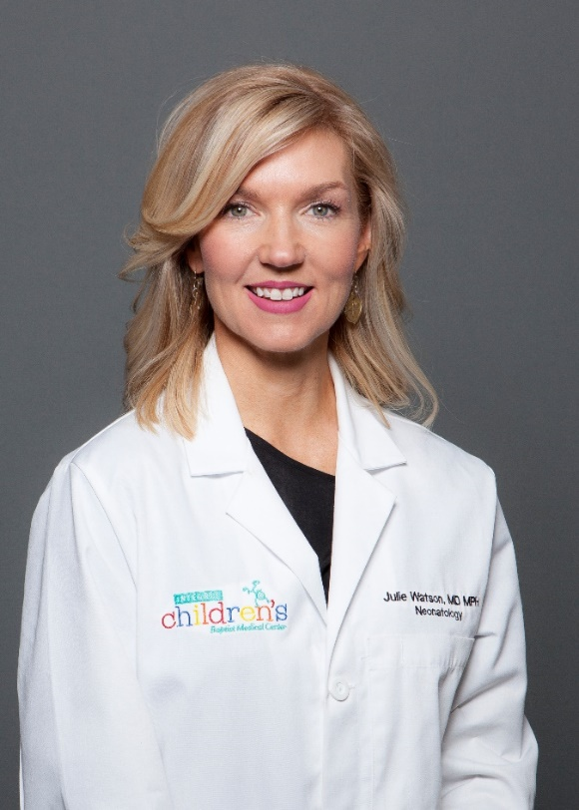
Julie Watson, MD MPH currently serves as the Senior Vice President and Chief Medical Officer for INTEGRIS Health. Previously, she served as Chief Medical Officer of INTEGRIS Baptist Medical Center from 2018 – 2020 and Vice President of Medical Affairs for the system from 2019-2020. She began her leadership career at INTEGRIS Baptist Medical Center in 2012, serving as the Department Chair of Pediatrics for six years.

A native of Oklahoma, Dr. Watson completed her undergraduate degree at OU and her Medical Degree from the University of Oklahoma College of Medicine. She completed her pediatric residency at Rush University Medical Center in Chicago and her neonatal-perinatal fellowship at Northwestern Feinberg School of Medicine in Chicago. She also holds a master’s degree in Public Health from the University of Illinois – Chicago with an emphasis in Health Policy. Following training, she returned to Oklahoma City in 2008 to begin her neonatology career in the NICU at INTEGRIS Baptist Medical Center as a board certified neonatologist. In 2018, she completed a certificate program in Fundamentals of Value Based Health Care through Dartmouth Institute.

Dr. Watson is a relationship and results-oriented physician leader who is passionate about co-creating shared purpose and vision, developing effective teams and talents and engaging others in improving outcomes that matter to patients, caregivers and communities. Her mission centers on helping providers see possibilities, leveraging existing and growing new relationships, leading culture change and using innovative operating models to achieve results.
She believes great leadership is evidenced by the success of those they lead. She could not be more proud of her clinical leader colleagues and all they accomplished and weathered over the last two years. She is also eternally grateful to her family for their sacrifices and support during this time. She will be forever in their debt.

